#### WEB ENGINEERING

PracticeReal.com

April 21, 2018

# Product Overview

For the semester project of web engineering, we are making PracticeReal.com PracticeReal.com is a platform which links students to the industry by providing a valid real word problems related to their field of study. The industries will get registered on the platform and will be able to post the tasks that are independent. The student will do the tasks for practice and the best solution will be used. 

## 

#### Arifullah Jan

#### Bilal Khalid

#### Saqib Shakeel

#### Waqas Yaseen

BSCS 6A

## Tools Used

We have used

1. Angular Framework
2. Github

Link: <https://github.com/ajanbscs16seecs/practice-real-angular>

1. Atom IDE
2. We followed material design guidelines.
3. This website is designed to work ajax. (Currently pages load without reloading of whole application)
4. Our website is fully responsive. It can be added to home screen on android devices.

# 

# Pages

## Home Page:

### Url: dashboard

Home page shows practice questions of user’s interests, based on what user searches ,reads or likes including the interests mentioned in the profile of the users.This will prevent the user to The contents are shown in material design cards.By clicking the task the user can directly go to the complete task link if it is not complete in the post ,there he can also solution or can see the present solutions for the task .User can also go to the profile of the person/company that has uploaded the task. So user can go through other tasks posted by the company

There is also a paginator which will be used to select how much tasks to load or shift to any page number by selecting it or typing the page number.

## 

## 

## 

## 

## 

## 

## 

## Sign in

### Url: /signin

In our signin page we have options of login and sign up for the new users. User can sign up using his email id and can set his username and password for further use or next time login. you can not login to the PracticeReal.com without your login id.

From the sign in page you can directly go to the home page if you want. By clicking on the logo of the website it takes you to the home page where you can perform other actions according to your requirement.



## Profile

### Url: /profile

This page is the profile page of the user. It contains information about the user such as the field of his/her expertise and the kind of tasks he/she can perform well.

The about tab in the user’s profile contains information about the user. The user provide all this information while creating a profile on PracticeReal. The information mainly contains the past experience of the user and the element that he/she is expert in.

The solutions tab is the tab where the users past record of PracticeReal is displayed. I.e the tasks that the user has solved on PracticeReal and all other kind of information related to each task solved by the user.

The users profile has his display picture along with his name and username.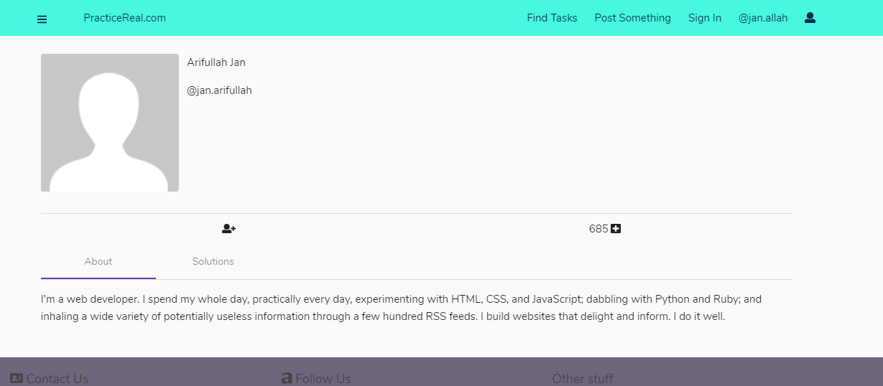

An important part about the user’s profile is user’s ratings. This is the part which gives Industrialists and idea about the user’s experience on PracticeReal which mainly every industrialist wants to know first. A user with higher rating is preferred always. Ratings change on the basis of solving tasks and the solutions quality.

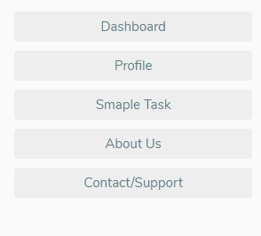

## Sidebar Component

We have a reusable sidebar component.

A single page can privately add other options too.

## Side Nav for mobile devices:

We have a side nav implemented so that we can easily make a progressive web app from this website which can be added to home screen on android devices through chrome.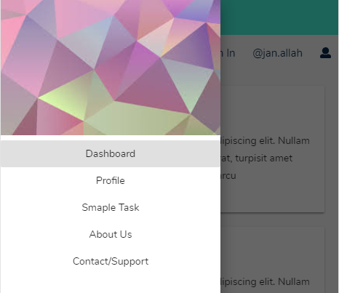

## Browse/Explore

### Url: /browse

We have a browse page where we have different categories of tasks for the users. Anyone can easily go there and easily find the tasks of his interests. User can search as well but in the categories there will be the detailed description of the tasks as well as their problem statements. In our website we have the mobile version as well as pc compatibility. This categorization will be very helpful for the companies to find the area of their interest.

## 

## Task Details Page

### Url: /task/[id]

This page will be displaying an individual task that a company or a individual posts. There are two tabs **discussions** and **submissions**.

In the discussion tab different people can discuss about the solution of some problem which will be very helpful because it will arise different type of the solutions and one can choose the most appropriate one.

In the submission tab there will be the final submission of the solution of tasks also there will be details of the task submitted by user like number of the tasks submitted. There will be a feedback after the submission of the task solution.

At the top of the task there will be the profile of the person who posted that task. Other users can also visit his profile to have a look at the other tasks he has posted.

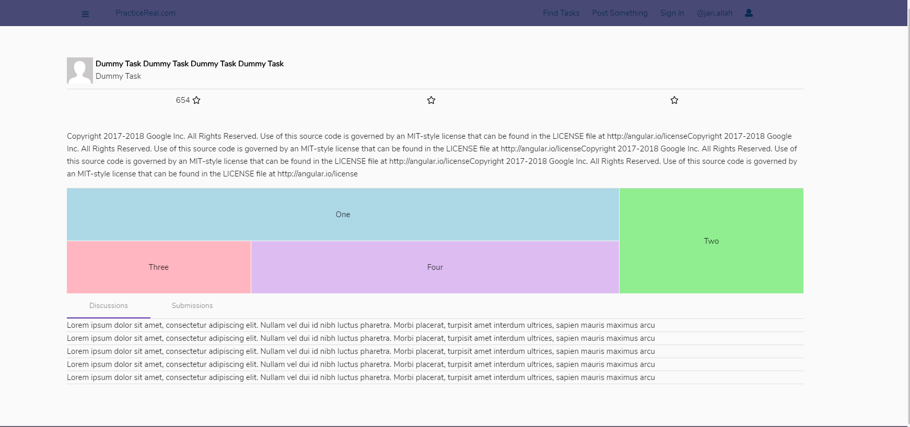

## Attachments

### Url: attachment/:id

This page is specifically concerned with the solutions for the task. All the attachments that the user uses for the solution of the task will be uploaded here.

E.g a if a user solves a problem that involves coding then there must be some attachment that contains the code that the user has typed. All those attachments would be be uploaded on this attachment page.

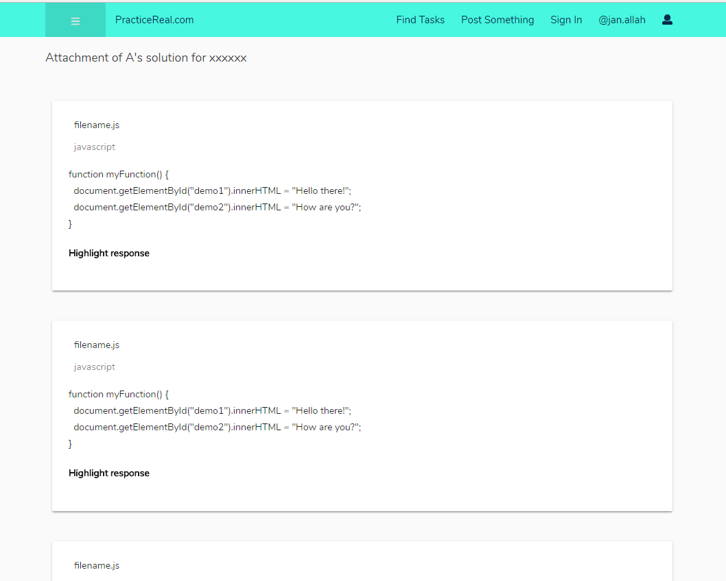

## Add Task

### Url: /new-task

There is a page for the users to post some task or their problem statement which they want to be solved. In this page the user will have to specify a title for their tasks also he will give a brief description about the problem. Then he has to select the category of the tasks. User can also upload some file from his pc or phone.

The company/user uploading the task can add as many tags as they want. This will help in the search when user searches the tasks using the specific keywords

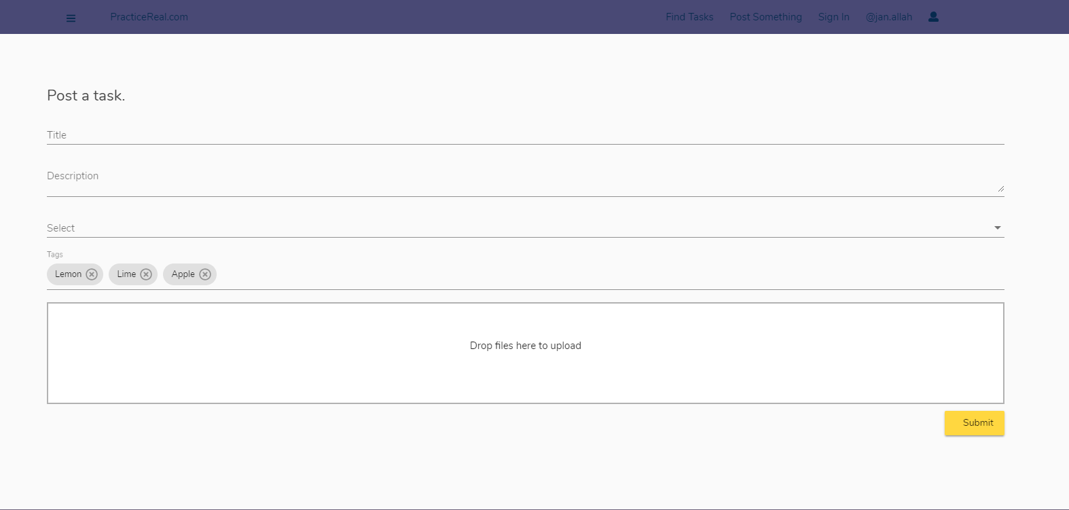

## Task Solution Submission

### Url: /task-submit/[id]

This page will be used to submit a solution for a specific task the id.

There is dropzone area where file can be dragged and dropped.This makes very easy for the users to upload the files on PracticeReal. Users can also click and browse to select a file or multiple.

There is checkbox which user need to mark in order to submit the document, this makes clear to user that there work can be reported if plagiarized giving a negative rating to the user’s profile or blocking the user as this activity is completly against the motive of PracticeReal .So user will surely try to submit his own work for the real practice and to build his own profile.

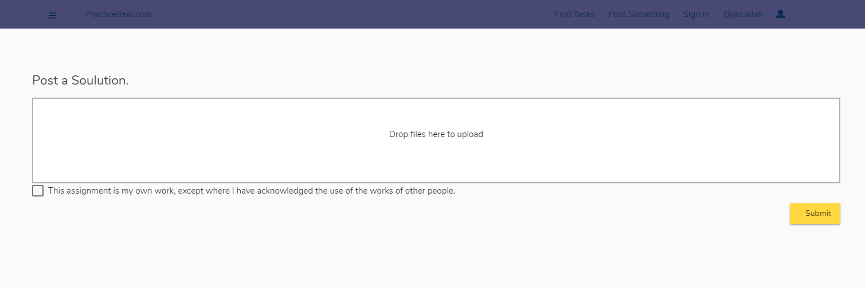

## Support

This page will help the user or some company’s representative to directly contact the developers or the management of PracticeReal.com .This would be very helpful to them in case of any issue with the website or if they want to report about anything .It may include reporting about some user,company or a specific task .User can also use this to give us a feedback about the website or if they have any suggestion which may help us to improve website for the best user experience.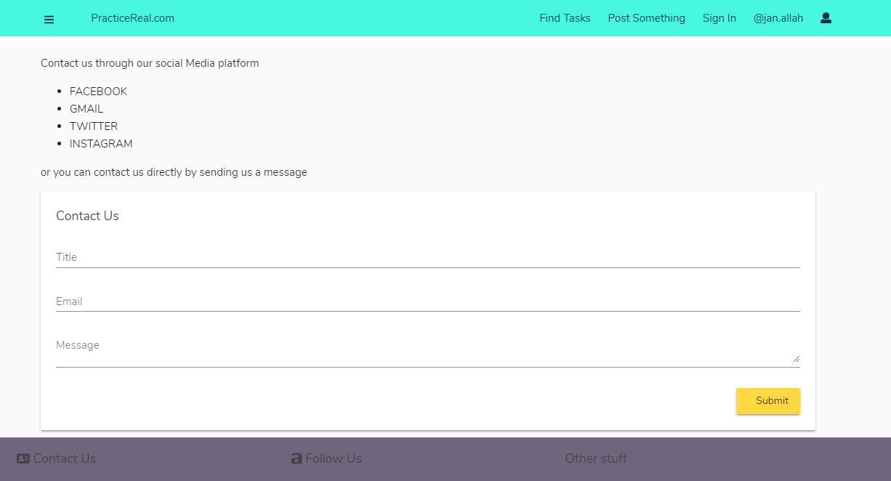

On the top there are some social media links if the user want to catch on any social media platform or he/she can use email to directly send us any kind of feedback.